PROCESS MANAGEMENT:
Process Concept  - An operating system executes a variety of programs:  - Batch system – jobs  - Time-shared systems – user programs or tasks  - Textbook uses the terms job and process almost interchangeably  - Process – a program in execution; process execution must progress in sequential fashion  - A process includes:  - program counter  - stack  - data section | Process In memory  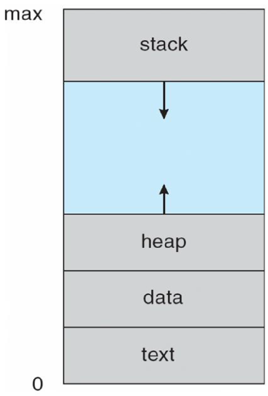
Process State

As a process executes, it changes state
- new: The process is being created
- running: Instructions are being executed
- waiting: The process is waiting for some event to occur
- ready: The process is waiting to be assigned to a processor
- terminated: The process has finished execution

Diagram of Process State
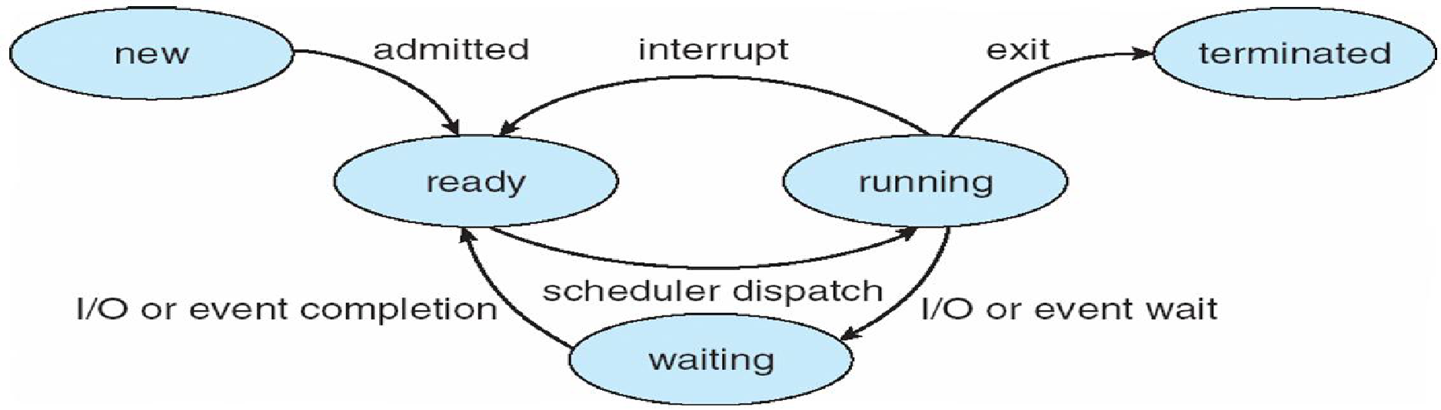
Process Control Block (PCB)  - Information associated with each process  - Process state  - Program counter  - CPU registers  - CPU scheduling information  - Memory-management information  - Accounting information  - I/O status information | 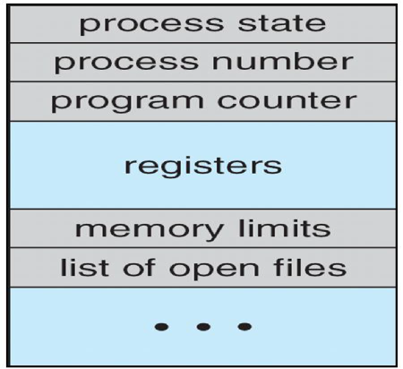

CPU Switch From Process to Process
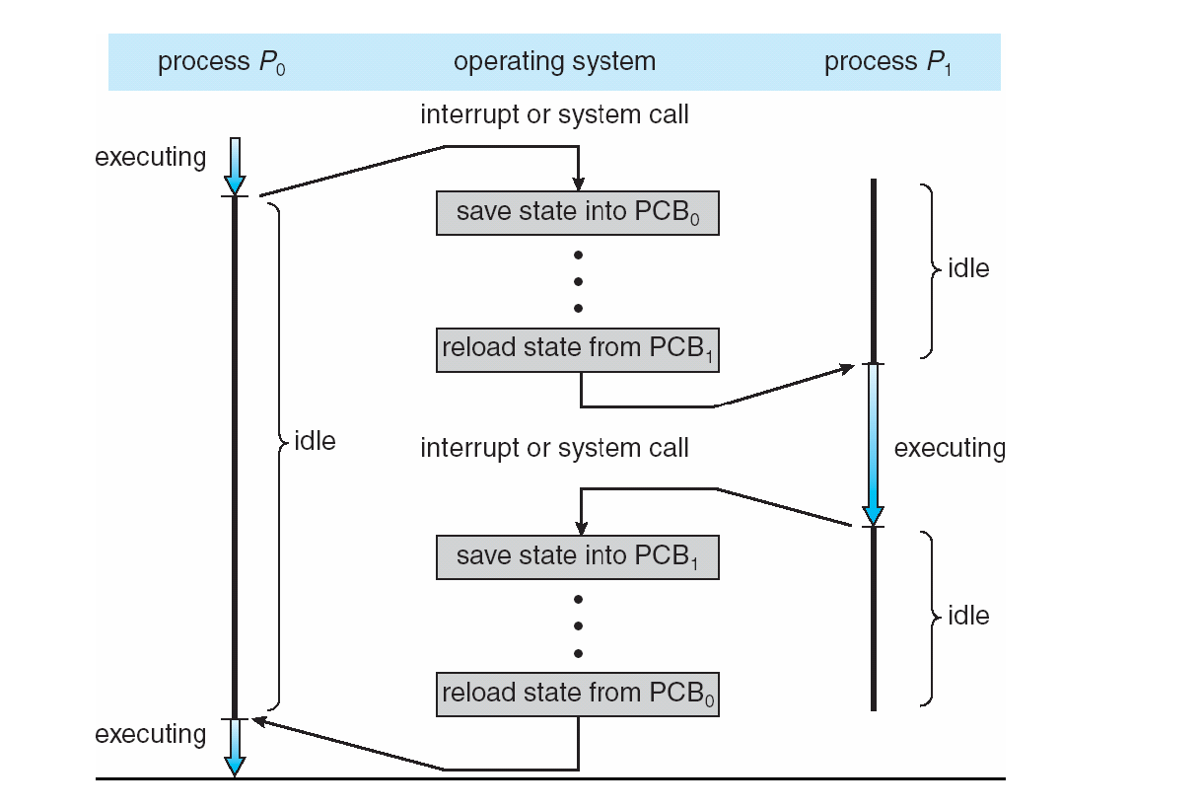
Process Scheduling Queues
Processes migrate among the various queues

- Job queue – set of all processes in the system
- Ready queue – set of all processes residing in main memory, ready and waiting to execute
- Device queues – set of processes waiting for an I/O device

Representation of Process Scheduling
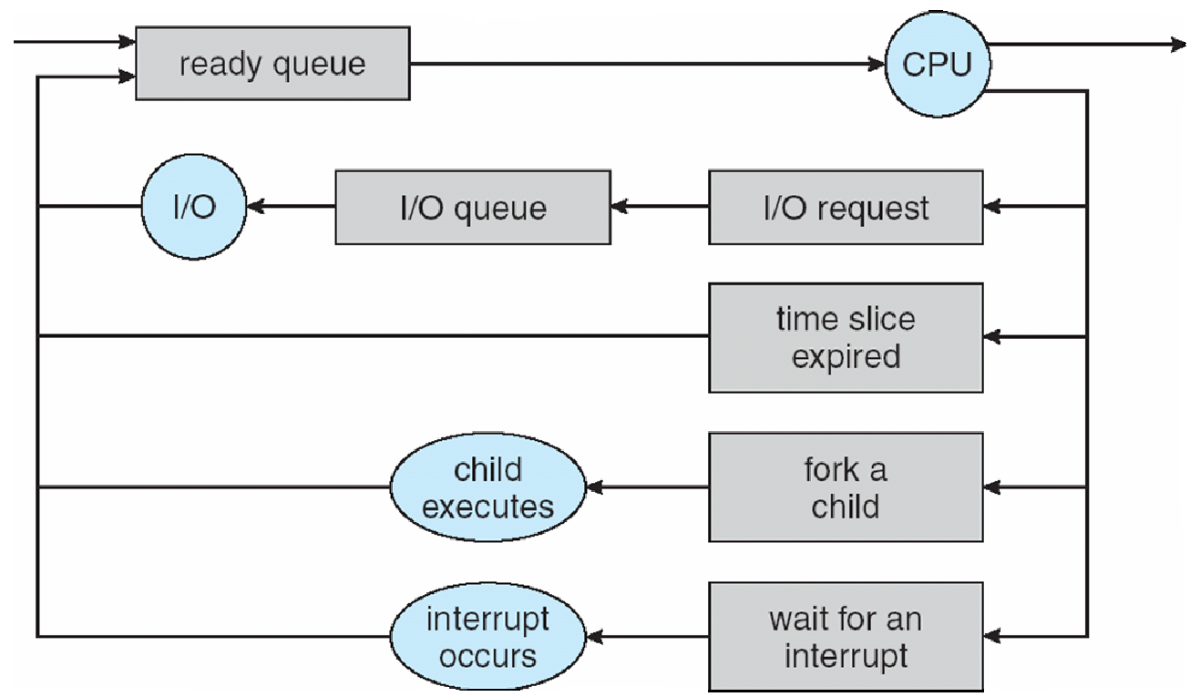
Schedulers
Long-term scheduler (or job scheduler) – selects which processes should be brought into the ready queue
Short-term scheduler (or CPU scheduler) – selects which process should be executed next and allocates CPU
Addition of Medium Term Scheduling
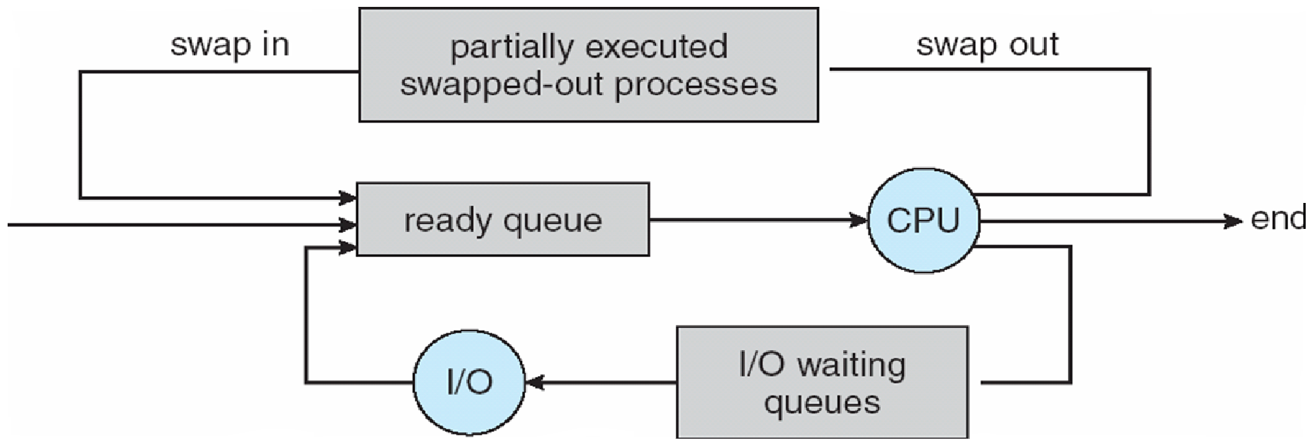

- Short-term scheduler is invoked very frequently (milliseconds) Þ (must be fast)
- Long-term scheduler is invoked very infrequently (seconds, minutes) Þ (may be slow)
- The long-term scheduler controls the degree of multiprogramming
Processes can be described as either:
- I/O-bound process – spends more time doing I/O than computations, many short CPU bursts
- CPU-bound process – spends more time doing computations; few very long CPU bursts
Context Switch
- When CPU switches to another process, the system must save the state of the old process and load the saved state for the new process via a context switch
- Context of a process represented in the PCB
- Context-switch time is overhead; the system does no useful work while switching
- Time dependent on hardware support

Process Creation
- Parent process create children processes, which, in turn create other processes, forming a tree of processes
- Generally, process identified and managed via a process identifier (pid)
- Resource sharing
- Parent and children share all resources
- Children share subset of parent’s resources
- Parent and child share no resources Execution
- Parent and children execute concurrently Parent waits until children terminate
- UNIX examples
  - fork system call creates new process
  - exec system call used after a fork to replace the process’ memory space with a new program
Process Creation
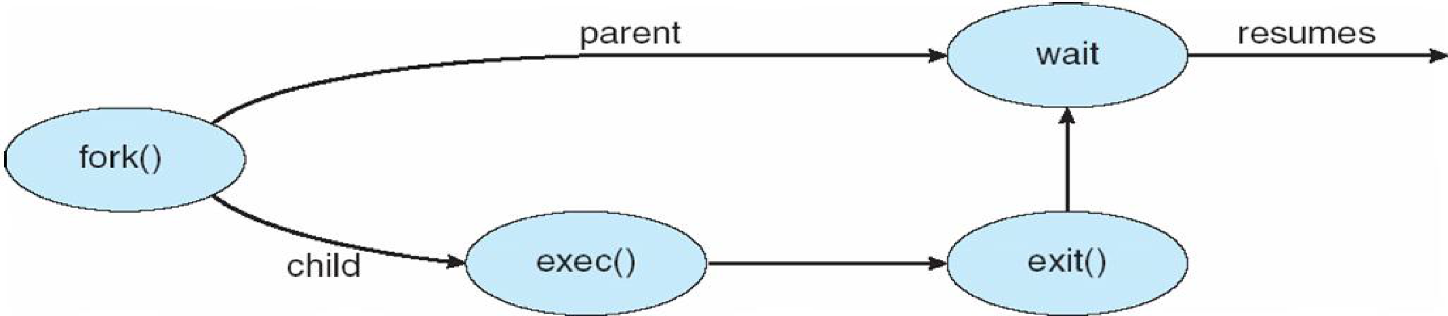
Process Termination
- Process executes last statement and asks the operating system to delete it (exit)
- Output data from child to parent (via wait)
- Process’ resources are deallocated by operating system
- Parent may terminate execution of children processes (abort)
- Child has exceeded allocated resources
- Task assigned to child is no longer required
- If parent is exiting Some operating system do not allow child to continue if its parent terminates

